

NAME: BISMA FATIMA
CLASS: CS A
ROLL NO: F24605036
COURSE: COMPUTER NETWORK
COURSE CODE: CS-271
LECTURER: SIR NAVEED YOUSAF

LAB 08

Subnetting & Configuring DNS

Warm up Task [30 Minutes]
Answer each question in your own words (3 to 4 lines)
• What is Subnetting?
Subnetting is the process of dividing a large network into smaller, manageable segments called subnets. It helps organize and control traffic within a network by assigning IP ranges to different departments or areas.
• Why Subnetting?
Subnetting is used to improve network efficiency, security, and scalability. It reduces congestion by limiting broadcast traffic and allows better control over IP address allocation.
• Benefits of Subnetting
- Enhances network performance by reducing broadcast domains
- Improves security through network segmentation
- Optimizes IP address usage
- Simplifies network management
• Broadcast Address
A broadcast address is used to send data to all devices within a subnet. It’s the highest address in a subnet and ends with all binary 1s in the host portion of the IP.
• Network Address
The network address identifies a specific subnet and is used to route traffic correctly. It’s the lowest address in a subnet and ends with all binary 0s in the host portion.
• What is Classless Inter-Domain Routing (CIDR)?
CIDR is a method for allocating IP addresses and routing that replaces the old class-based system. It uses variable-length subnet masking (e.g., /24) to allow more flexible and efficient IP address usage.
• What is DNS?
DNS (Domain Name System) translates human-readable domain names like www.example.com into IP addresses that computers use to communicate. It acts like the internet’s phonebook.
• What is Address Resolution?
Address resolution is the process of mapping a logical IP address to a physical MAC address. It’s essential for devices to locate each other on a local network.
• Difference between DNS Resolver and DNS Authoritative Server
- DNS Resolver: A client-side service that queries DNS servers to resolve domain names.
- DNS Authoritative Server: Holds the actual DNS records and provides the final answer to queries about domains it manages.
• What is ARP and how does it work?
ARP (Address Resolution Protocol) is used to find the MAC address of a device given its IP address. It sends a broadcast request asking “Who has this IP?” and the device with that IP replies with its MAC address.

Task 1
Design University network topology diagram in Cisco Packet Tracer according to the given requirements. University network is divided into Four blocks and each block has different host requirements
- CS Block: 136 hosts
- AI Block: 95 hosts
- SE Block: 51 hosts
- CE Block: 24 hosts
Requirements:
- Apply concept of subnetting and use IP address of class C.
- Assign IP addresses to routers, switches, and PCs based on the subnetting scheme.
- Label each block and device in the topology.
- Ensure proper connectivity within each block and test the network.

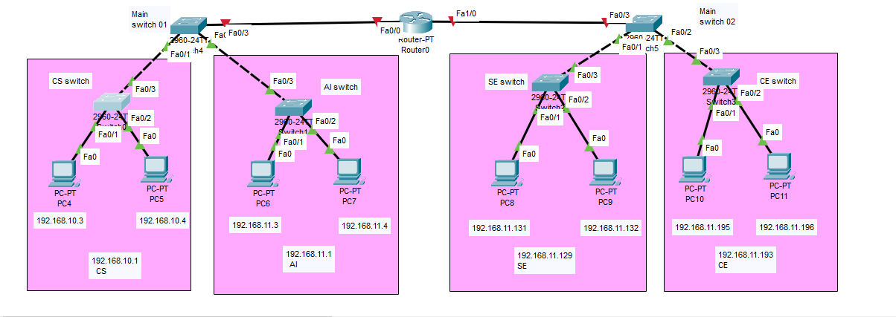
SWITCH CONFIGRATION
SWITCH CS
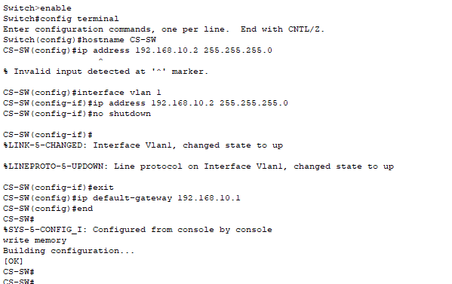
SWITCH AI
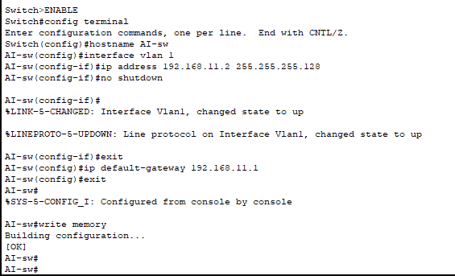
MAIN SWITCH 01
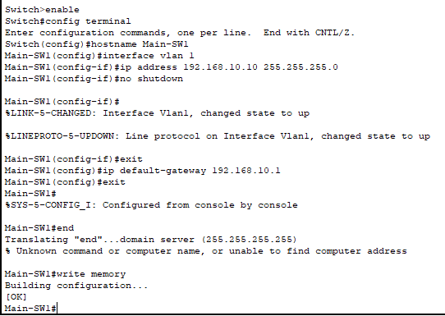
SWITCH SE
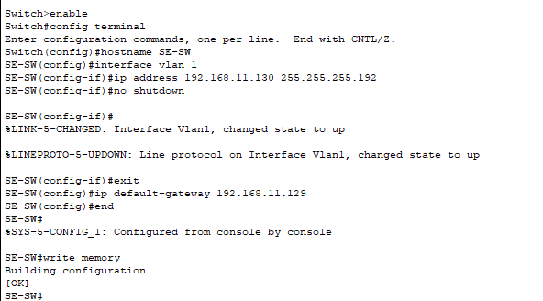
SWITCH AI
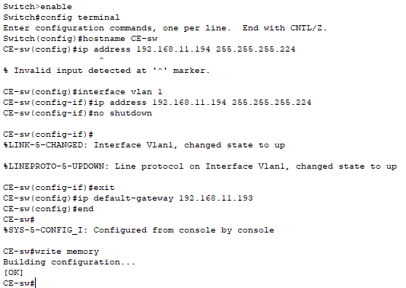
MAIN SWITCH 02
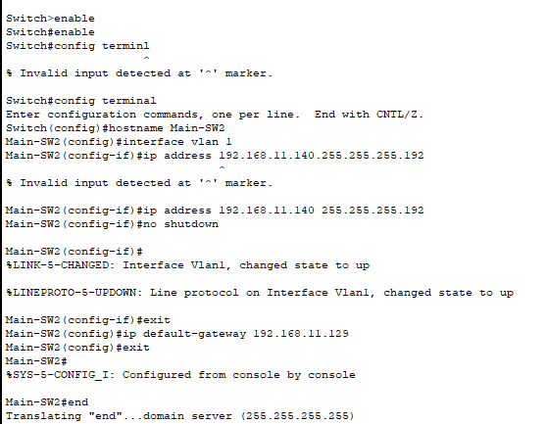

ROUTER CONFIGRATION
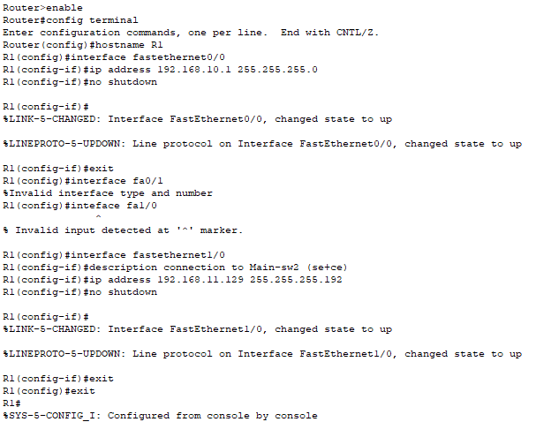
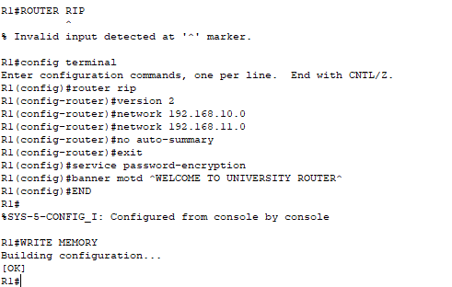
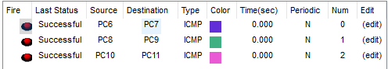

Task 2
Design topology diagram in Cisco Packet Tracer according to the given requirements. University network is divided into Four blocks and each block has different host requirements

The network consists of the following components:
- 4 PCs
- Two Switches
- One DNS Server (DNS Server)
PCs needs to resolve the domain name "www.NUTECH.com" to an IP address using the DNS Server. Configure the network components to ensure that PCs can successfully resolve the domain name.

Task 2 Topology Diagram
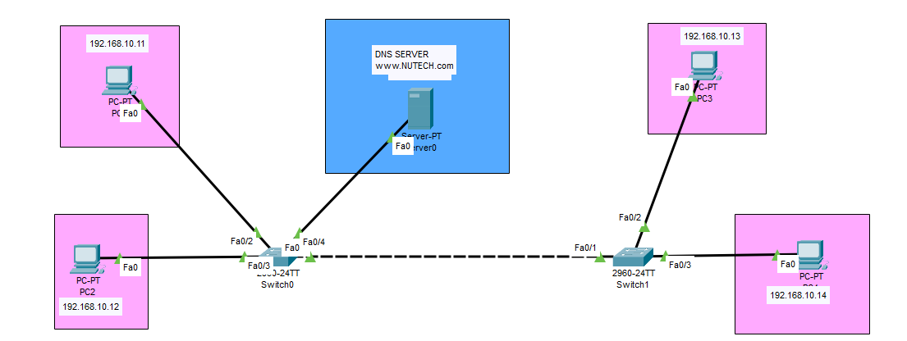
Pinging

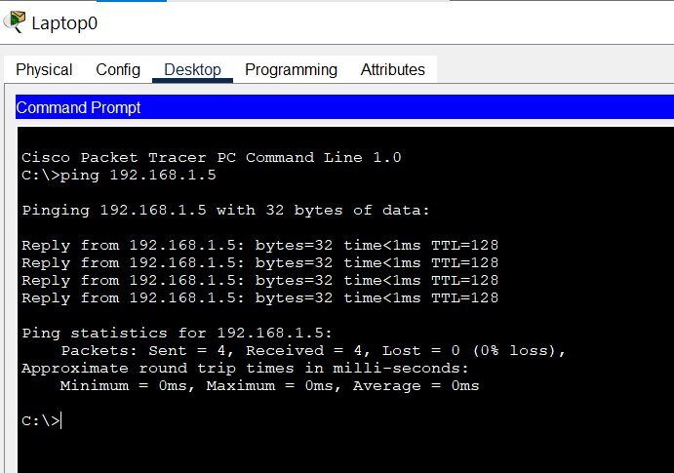

Enable DNS Service
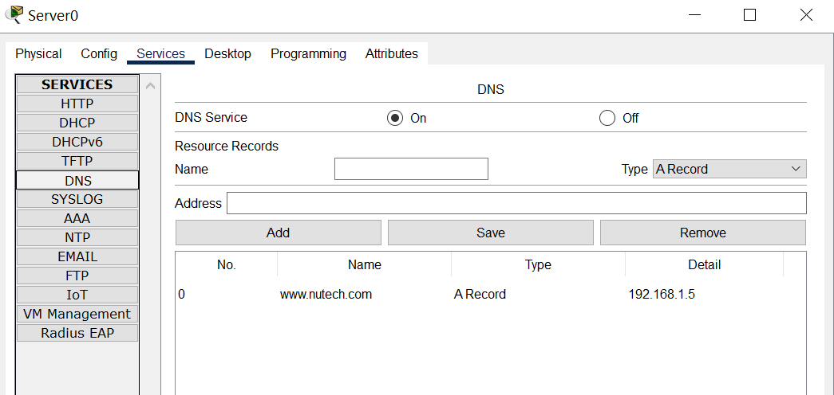

Test DNS name resolution

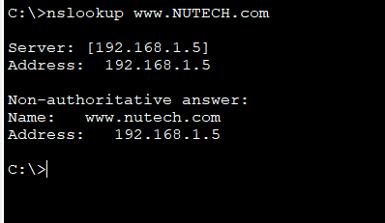

Task 3
Implement Task 2 topology with DNS resolver, DNS authoritative server and website of your name for example (abc.html). Content of website consist of your Bio Data.
Task 3 Topology Diagram
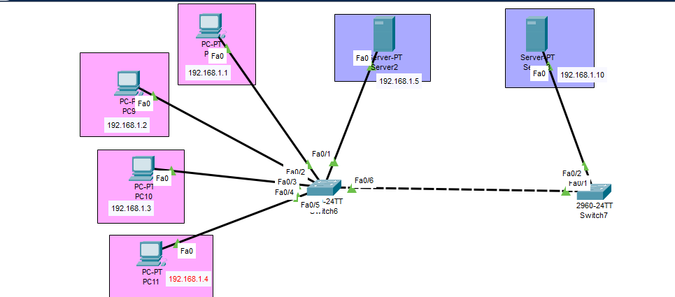
Assign IP Address
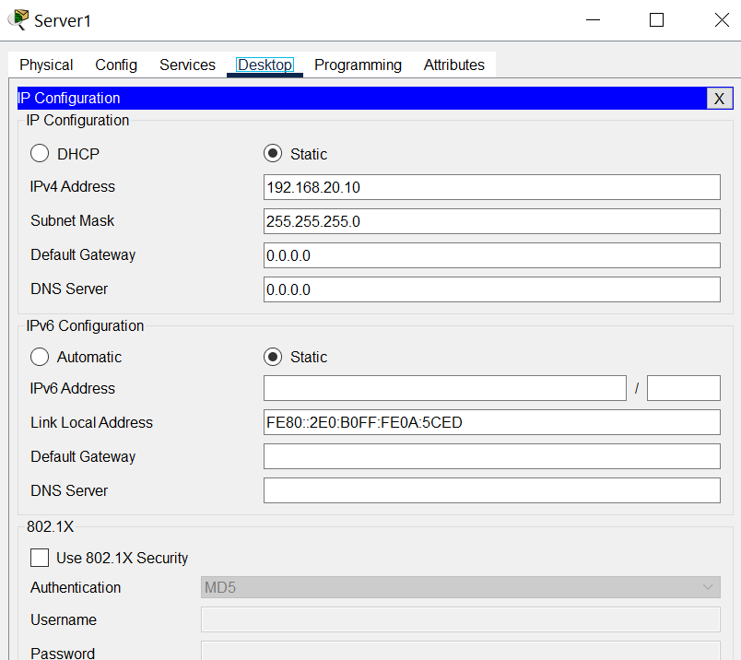

Enable DNS Service
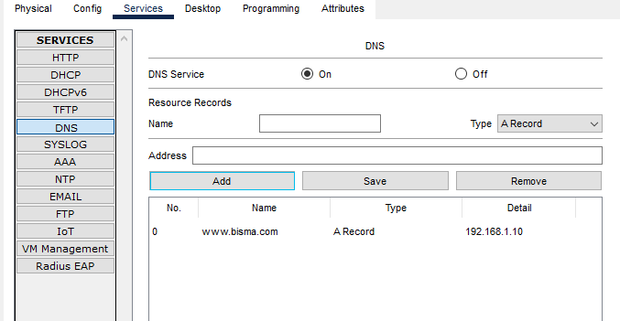

Host Your Website (Bio Data)
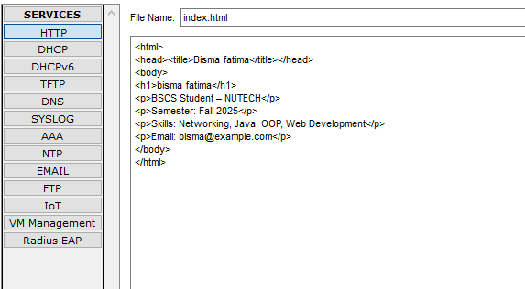
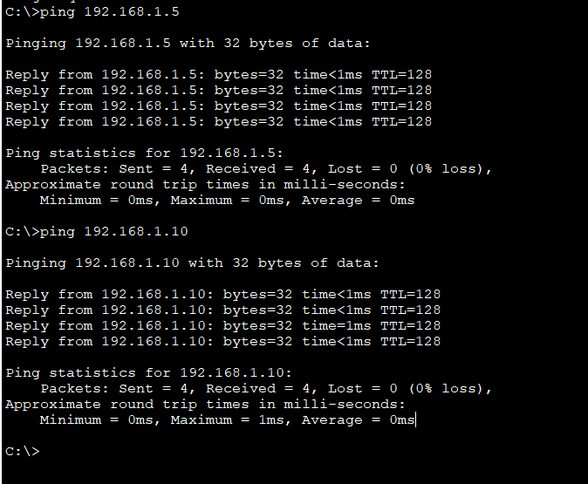
Verification

Result
